**NBMS/BMS**

|  |  |  |
| --- | --- | --- |
| **Account No : 9024662852 Invoice No: SDCAP0017800826**  **Invoice Date : 01/01/2022 Billing Period** | | |
|  | **01/12/2021 to 31/12/2021** | |
| **Tariff plan: 5GB CUL** | | |
| **AMOUNT PAYABLE**  R **860.00**  [**PAY NOW**](http://portal2.bsnl.in/myportal/QRService/initiaterequest.do?msg=08772276786%7C9024662852%7CSDCAP0017800826%7CCDR%7C860%7CAP%7CNA%7CNA) | | **DUE DATE 20/01/2022** |

**Postage Paid in Advance Tax Invoice**

**PURUSHOTHAM S.**

#7-84

MATHA STREET NEWPET CHANDRAGIRI CHITTOOR AP 517101

**TELEPHONE NUMBER 08772276786**

Account Summary

**(-)**

R **860.00**

**PAYMENT RECEIVED**

^ð ÍÏ…_¯è Ðð $$™è ¢…

R **0.00**

**ADJUSTMENTS**

çÜÆæ $ªºés $

R **859.46**

**PREVIOUS BALANCE**

Ðè $$…§æ Ç ¼Ë$Ï

**(+)**

**(+)**

**(=)**

**(=)**

Amount in words : Eight Hundred and Sixty Only.

R

**Amount**

65.61

65.61

**Tax Rate**

9.00%

9.00%

**Description**

CGST

SGST

**729.00**

**0.00**

**0.00**

**0.00**

**0.00**

**0.00**

**729.00**

**131.22**

**860.22**

¯ð ËçÜÇ ^êÈj

JMæ PÝëÇ ^êÈjË$ Ðêyæ $Mæ Ðð $$™è ¢…

ÆéÄ $¡Ë$ BËçÜÅ ^ð ÍÏ…ç³#

sêMŠ Þ

Ðð $$™è ¢… ¼Ë$Ï

Recurring Charges

One Time Charges Usage Charges

Miscellaneous Charges Discounts

Late Fee

Total Taxable (Rs.) Tax

Total Current Charges

**Amount**

{ç³çÜ$¢™è ¼Ë$Ï

**Current Charges**

**Summary of Charges**

**6 Paisa Cash Back Offer Amount 0.00**

**Tax Details**

Jun'20 Jul'20 Aug'20 Sep'20 Oct'20 Nov'20

0 GB

0 Min

30 GB

1 Min

60 GB

2 Min

90 GB

3 Min

120 GB

4 Min

150 GB

5 Min

**Voice(Min)**

**Data(GB)**

**USAGE HISTORY (6 MONTHS)**



|  |  |  |  |  |  |  |  |  |  |  |  |  |  |  |  |  |  |  |  |  |  |  |  |  |  |  |  |  |  |  |  |  |  |  |  |  |  |  |  |
| --- | --- | --- | --- | --- | --- | --- | --- | --- | --- | --- | --- | --- | --- | --- | --- | --- | --- | --- | --- | --- | --- | --- | --- | --- | --- | --- | --- | --- | --- | --- | --- | --- | --- | --- | --- | --- | --- | --- | --- |
| **- PAYMENT SLIP -** | | | | | | **Invoice No** | | | | | | | | | | | | | | | | | | **SDCAP0017800826** | | | | | | | | | | | | | | | |
| **BHARAT SANCHAR NIGAM LTD Mode of payment**  Cash Cheque/DD Credit/Debit Card  Cheque/DD No. Dated Bank Branch Please Charge Rs. Signature | | | | | | **Invoice Date** | | | | | | | | | | | | | | | | | | **01/01/2022** | | | | | | | | | | | | | | | |
| **Account No** | | | | | | | | | | | | | | | | | | **9024662852** | | | | | | | | | | | | | | | |
| **Phone No** | | | | | | | | | | | | | | | | | | **08772276786** | | | | | | | | | | | | | | | |
| **Due Date** | | | | | | | | | | | | | | | | | | **20/01/2022** | | | | | | | | | | | | | | | |
| **Amount Payable** | | | | | | | | | | | | | | | | | | R **860.00** | | | | | | | | | | | | | | | |
|  |  |  |  |  |  |  |  |  |  |  |  |  |  |  |  |  |  |  |  |  |  |  |  |  |  |  |  |  |  |  |  |  |  |  |  |  |  |  |  |
| Please make crossed Cheque/DD/Pay order for Amount Payable (Rounded Up) in favour of AO (Cash), BSNL, Tirupati. **For Bank use only** | | | | | | | | | | | | | | | | | | | | | | | | | | | | | | | | | | | | | | | |

# This is a Computer generated Bill and does not require any Signature.

**860.22**

R

**CURRENT CHARGES**

{ç³çÜ$¢™è ¼Ë$Ï

R **859.68**

**TOTAL DUE**

¼Ë$Ï Ðð $$™è ¢…

R **860.00**

**AMOUNT PAYABLE**

¼Ë$Ï Ðð $$™è ¢…



**BSNL Wishes You a very Happy and Prosperous New Year 2021.**

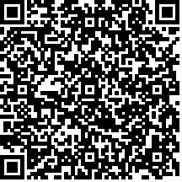

**Accounts Officer (TR)**

Scan 'QR' code for making Bill Payment through Internet.

**Dear Customer, In view of COVID-19 pandemic, be safe & avoid venturing out. We recommend you to pay the bill online using https://portal.bsnl.in/ or**

**use My BSNL App on your mobile to avail our services 24X7. My BSNL App is available on the Google play. #Unite2FightCorona**

Page 1 of 4



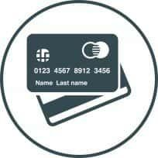Account No: 9024662852 | Invoice No: SDCAP0017800826 | Invoice date: 03/01/2021

|  |  |
| --- | --- |
| **WAYS TO PAY BILL**  **Click to Pay Drop your cheque/DD at BSNL bill**  **For online payment log on to** [**www.bsnl.co.in**](http://www.bsnl.co.in/) **collection centers**  **Pay at any BSNL Retailer Outlet. Pay at any Post Offices on or before Due Date**  **Pay at any BSNL Customer Service Pay through My BSNL App**  **Centers (CSC's) & CTO's / DTO's Download My BSNL App to avail BSNL**  **services & making bill payments**  **Pay your bill in time and save on late fees charges of 2% of billed amount (Min. Rs.10/-).**  **CUSTOMER CARE**   * Dial Toll Free Number **1500** for (Landline/Broadband) from BSNL Numbers and **1800-345-1500** from all other Service Provider Numbers. * Dial Toll Free Number **1503** for (Mobile) from BSNL Numbers and **1800-180-1503** from all other Service Provider Numbers. * Dial **198** from BSNL numbers for Automatic Fault Booking. * Log on to web selfcare portal [**www.selfcare.bsnl.co.in**](http://www.selfcare.bsnl.co.in/) * Download My BSNL App to avail BSNL services & making bill payments. * Reverse Charges Not Applicable   **BSNL GO-GREEN INITIATIVE**  Say no to Paper Bill, opt for " Bill on Email Only " option & get discount of Rs.10/- per bill for 10 months. Register for E-bill at  [**www.selfcare.bsnl.co.in**](http://www.selfcare.bsnl.co.in/) or visit nearest BSNL CSC  **Account Officer address**:O/o General Manager, Sanchar Bhavan, Near HPO Compound, Tirupathi, Andhra Pradesh - 517501  **CUSTOMER INFORMATION**   * Get the last bill details on your mobile, SMS '**BILL<Space><STDCODE-TEL.NO><Space><BILLING ACCOUNT NO>** on 53334 from   BSNL Mobile and for Non BSNL Mobile on 9478053334   * Logon to [**www.bsnl.co.in**](http://www.bsnl.co.in/) for information on the tariff plans and prices * For change of billing address, please contact your nearest customer care or AO (TR) / Commercial Officer of your exchange area. * If your mobile/landline is used for sending unsolicited commercial communication (UCC) through SMS or Voice, it leads to   disconnection of your telecom resources and blacklisting for two years   * For contact details of Nodal Officer / Appellate Authority, tariffs and other information, visit our website [**www.bsnl.co.in**](http://www.bsnl.co.in/) * Disputes if any, should be brought to the notice of the concerned AO(TR) within 60 days. | |
| **Installation Address:**#7-84,MATHA STREET,MATHA STREET,CHANDRAGIRI,TIRUPATI,Andhra Pradesh -517101 | * **GST Registration Number:** 37AABCB5576G3ZI • **PAN Number:** AABCB5576G   • **HSN/SAC Code:** 998412 • **CIN:**U74899DL2000GOI107739 |



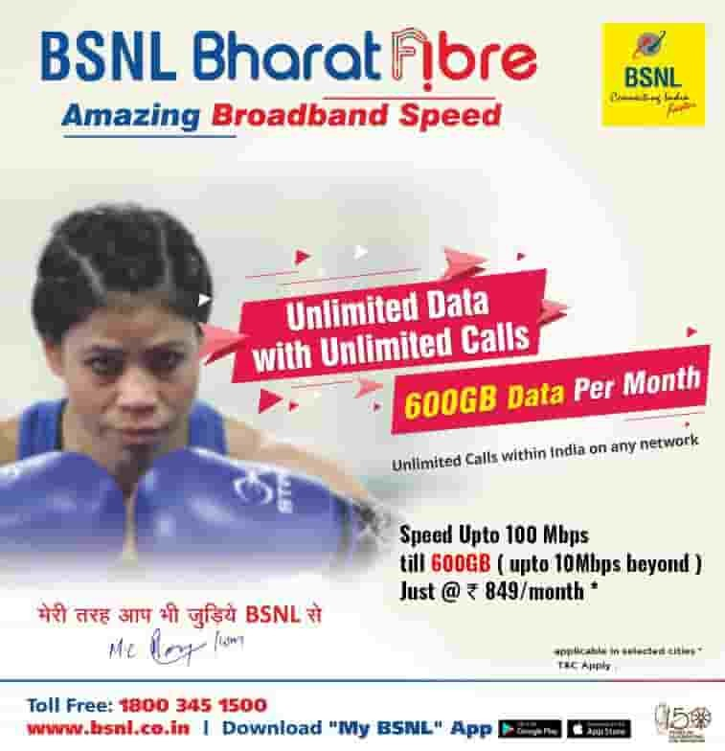

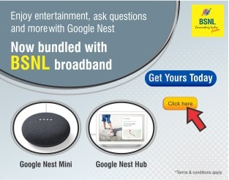

|  |  |
| --- | --- |
| **DETAILS OF CURRENT CHARGES** | |
| **Payment Details** |  |
| Description Date | Amount(Rs.) |
| Bill Desk Payment 16/12/2020 | 860.00 |
| **Total** | **860.00** |
| **List of Services** |  |
| **Phone Number/Service ID Monthly Charges Usage Charges One Time Charges** | **Discounts** |
| 08772276786 0.00 0.00 0.00 | 0.00 |
| cd76786_scdrid 729.00 0.00 0.00 | 0.00 |
| **Phone Number/Service ID | 08772276786** |  |
| **Installation Address:** |  |
| #7-84,MATHA STREET,MATHA STREET,CHANDRAGIRI,TIRUPATI,Andhra Pradesh -517101 |  |
| **Plan 701583/5GB CUL** |  |
| **Phone Number/Service ID | cd76786_scdrid** |  |
| **Installation Address:** |  |
| #7-84,,MATHA STREET,,MATHA STREET,,CHANDRAGIRI,,TIRUPATI,,Andhra Pradesh - -517101 |  |
| **Plan 701583/5GB CUL** |  |
| **Monthly Charges** |  |
| Description & HSN / SAC Code Start Date End Date | Amount(Rs.) |
| BB - Fixed Monthly Charge-998412 01/12/2020 31/12/2020 | 729.00 |
| **Total** | **729.00** |

|  |  |
| --- | --- |
| **CURRENT CHARGES ANALYSIS** | |
| r 729.00 |  |
|  | r 131.22 |
| Recurring Charges | Tax |
| One Time Charges | Adjustments |
| Miscellaneous Charges | Usage Charges |



|  |  |  |  |  |  |  |  |
| --- | --- | --- | --- | --- | --- | --- | --- |
| **DETAILS OF CURRENT CHARGES**  **Phone Number/Service ID | cd76786_scdrid**  **Installation Address:**  #7-84,,MATHA STREET,,MATHA STREET,,CHANDRAGIRI,,TIRUPATI,,Andhra Pradesh - -517101 | | | | | | |  |
|  | **Plan 701583/5GB CUL** |  |  |  |  |  |
|  | **Usage Charges** |  |  |  |  |  |
|  | Data | Units | Volume (GB) | Gross Amt | Disc | Charges |  |
|  | Broadband Day Usage | 108115286 | 103.11 GB | 0.00 | 0.00 | 0.00 |  |
|  | BB Night Usage (2AM-8AM) | 2170434 | 2.07 GB | 0.00 | 0.00 | 0.00 |  |
|  | **Total** | **110285720** | **105.18 GB** | **0.00** | **0.00** | **0.00** |  |